K means Clustering in R

2023-05-04

In this R notebook, we will explore the use of k-means clustering as a technique for unsupervised learning. Specifically, we will apply k-means clustering to a dataset and examine the results of clustering using 3, 4, and 5 clusters.

# import data set  
buddymove_holidayiq = read.csv("~/Documents/Langara /Semester 3/DANA 4840 Classification II/Activities/Kmeans Clustering/buddymove_holidayiq.csv", stringsAsFactors=TRUE)  
attach(buddymove_holidayiq)  
  
# view data set  
head(buddymove_holidayiq)

## User.Id Sports Religious Nature Theatre Shopping Picnic  
## 1 User 1 2 77 79 69 68 95  
## 2 User 2 2 62 76 76 69 68  
## 3 User 3 2 50 97 87 50 75  
## 4 User 4 2 68 77 95 76 61  
## 5 User 5 2 98 54 59 95 86  
## 6 User 6 3 52 109 93 52 76

# remove first column  
data = buddymove_holidayiq[1:30,-c(1)]  
head(data)

## Sports Religious Nature Theatre Shopping Picnic  
## 1 2 77 79 69 68 95  
## 2 2 62 76 76 69 68  
## 3 2 50 97 87 50 75  
## 4 2 68 77 95 76 61  
## 5 2 98 54 59 95 86  
## 6 3 52 109 93 52 76

#scale data   
data_scaled = scale(data)  
head(data_scaled)

## Sports Religious Nature Theatre Shopping Picnic  
## 1 -1.4466673 -0.08420654 -0.3809810 -0.7600042 -0.40226206 0.74708109  
## 2 -1.4466673 -0.84206543 -0.5017144 -0.2960481 -0.35239486 -1.30422630  
## 3 -1.4466673 -1.44835254 0.3434194 0.4330256 -1.29987162 -0.77240587  
## 4 -1.4466673 -0.53892188 -0.4614699 0.9632611 -0.00332448 -1.83604674  
## 5 -1.4466673 0.97679590 -1.3870926 -1.4227985 0.94415228 0.06331196  
## 6 -0.5609526 -1.34730469 0.8263530 0.8307022 -1.20013722 -0.69643152

library(factoextra)

## Loading required package: ggplot2

## Welcome! Want to learn more? See two factoextra-related books at https://goo.gl/ve3WBa

fviz_nbclust(data_scaled, kmeans, method = "wss") + geom_vline(xintercept = 3, linetype = 2)

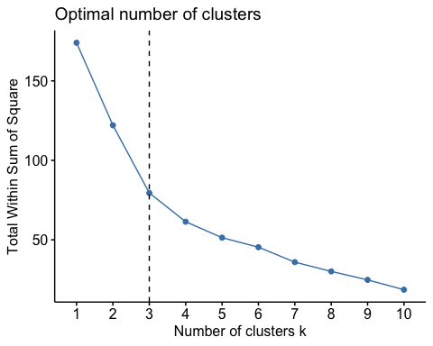

K-means with 3 clusters

####### 3 clusters #######  
  
#clustering algorithm  
km.res = kmeans(data, 3, nstart = 25)  
  
#mean of each variable in each cluster  
km.res$centers

## Sports Religious Nature Theatre Shopping Picnic  
## 1 4.000000 61.80000 117.30000 82.80000 56.0000 89.60000  
## 2 3.384615 76.46154 82.38462 85.53846 75.0000 79.38462  
## 3 3.571429 106.85714 58.57143 67.71429 106.7143 89.57143

#size in each cluster   
km.res$size

## [1] 10 13 7

#mean using original data   
aggregate(buddymove_holidayiq[1:30,-c(1)], by=list(cluster=km.res$cluster), mean)

## cluster Sports Religious Nature Theatre Shopping Picnic  
## 1 1 4.000000 61.80000 117.30000 82.80000 56.0000 89.60000  
## 2 2 3.384615 76.46154 82.38462 85.53846 75.0000 79.38462  
## 3 3 3.571429 106.85714 58.57143 67.71429 106.7143 89.57143

#graphing of clusters   
fviz_cluster(km.res, data = data,  
 palette = c("#2E9FDF", "#00AFBB", "#E7B800", "#FC4E07"),   
 ellipse.type = "euclid", # Concentration ellipse  
 star.plot = TRUE, # Add segments from centroids to items  
 repel = TRUE, # Avoid label overplotting (slow)  
 ggtheme = theme_minimal()  
)

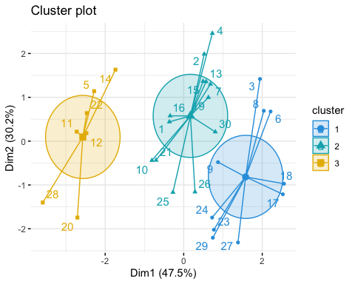

K-means with 4 clusters

####### 4 clusters #######  
#clustering algorithm  
km.res4 = kmeans(data, 4, nstart = 25)  
  
#mean of each variable in each cluster  
km.res4$centers

## Sports Religious Nature Theatre Shopping Picnic  
## 1 3.600000 54.20000 113.60000 96.60000 53.2000 79.60000  
## 2 4.400000 69.40000 121.00000 69.00000 58.8000 99.60000  
## 3 3.384615 76.46154 82.38462 85.53846 75.0000 79.38462  
## 4 3.571429 106.85714 58.57143 67.71429 106.7143 89.57143

#graphing of clusters   
fviz_cluster(km.res4, data = data,  
 palette = c("#2E9FDF", "#00AFBB", "#E7B800", "#FC4E07"),   
 ellipse.type = "euclid", # Concentration ellipse  
 star.plot = TRUE, # Add segments from centroids to items  
 repel = TRUE, # Avoid label overplotting (slow)  
 ggtheme = theme_minimal()  
)

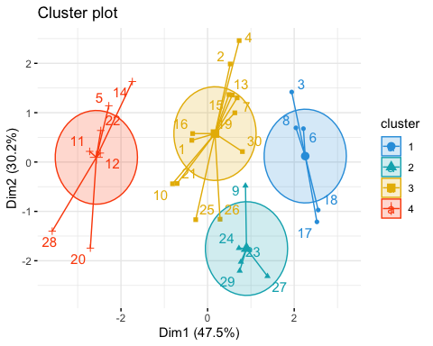

K-means with 5 clusters

####### 5 clusters #######  
#clustering algorithm  
km.res5 = kmeans(data, 5, nstart = 25)  
  
#mean of each variable in each cluster  
km.res5$centers

## Sports Religious Nature Theatre Shopping Picnic  
## 1 4.400000 69.40000 121.00000 69.00000 58.80000 99.60000  
## 2 3.600000 54.20000 113.60000 96.60000 53.20000 79.60000  
## 3 3.666667 84.83333 84.83333 77.83333 74.83333 92.00000  
## 4 3.142857 69.28571 80.28571 92.14286 75.14286 68.57143  
## 5 3.571429 106.85714 58.57143 67.71429 106.71429 89.57143

#graphing of clusters   
fviz_cluster(km.res5, data = data,  
 ellipse.type = "euclid", # Concentration ellipse  
 star.plot = TRUE, # Add segments from centroids to items  
 repel = TRUE, # Avoid label overplotting (slow)  
 ggtheme = theme_minimal()  
)

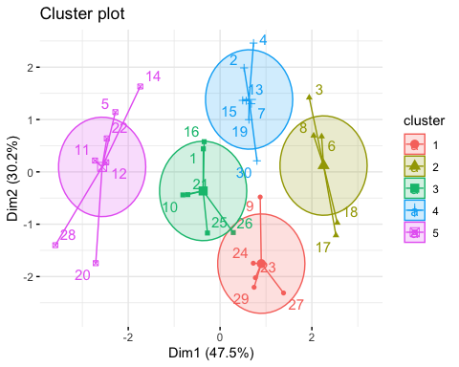

5 clusters seems to be appropriate